Work India
- SignIn/Signup (Mobile + OTP /Email + OTP Verification) for Employer
- SignIn/Signup (Mobile + OTP) for candidates
- Post a Job (predefined collar Jobs + Description + Type)
- Company Name, Size, location, and no of Requirement (Checkbox), How soon to fill in the position,
- Parttime/full time
- Job location => city + location
- Candidate requirement (Any, Fresher Only, Experienced Only)
- Monthly In Hand Salary (Min + Max)
- Bonus offer in addition to monthly salary
- Job info/Job description( Total experience, Min/Max experience,Min Qualification,Gender preference, English Requirement, Candidate location range, ready to relocate ??,Assets required : PAN Card, Aadhar card, Driving license ,etc )
- Candidates can call (weekly, daily, custom)
- Job timings, Address how soon to be filled (immediately, one-3 months)
- Screenshot : (https://www.workindia.in/employers/jobposts/edit/16566557/)
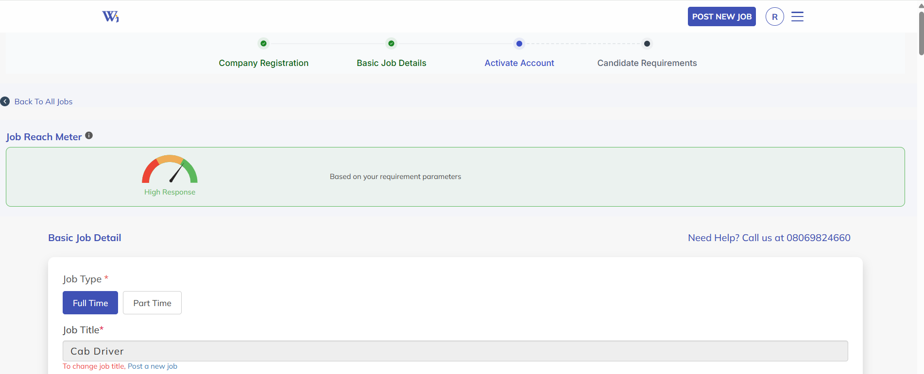

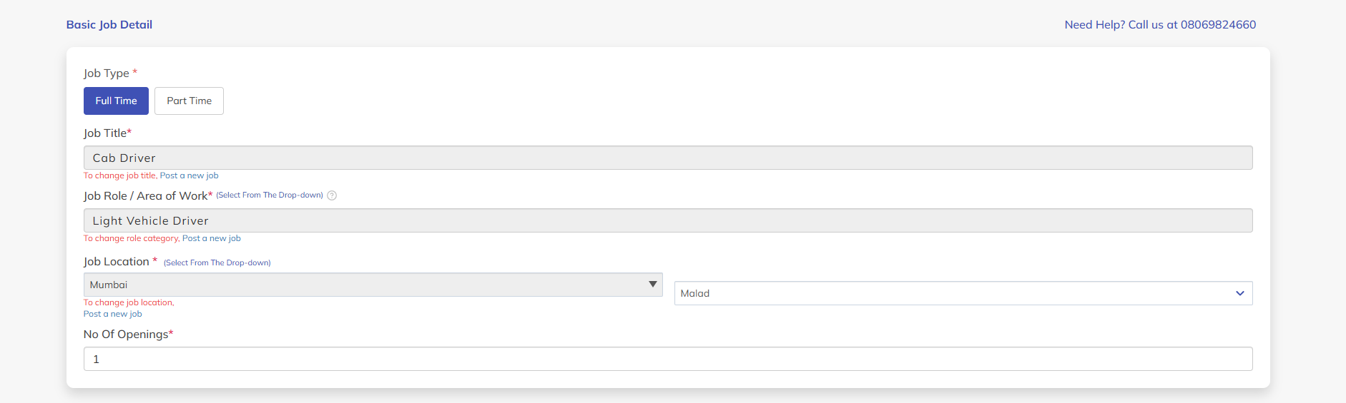
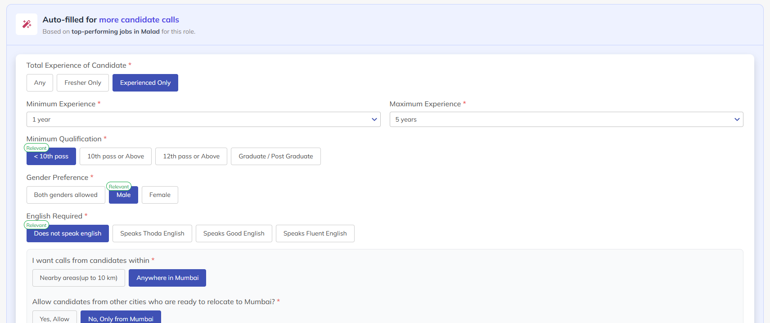
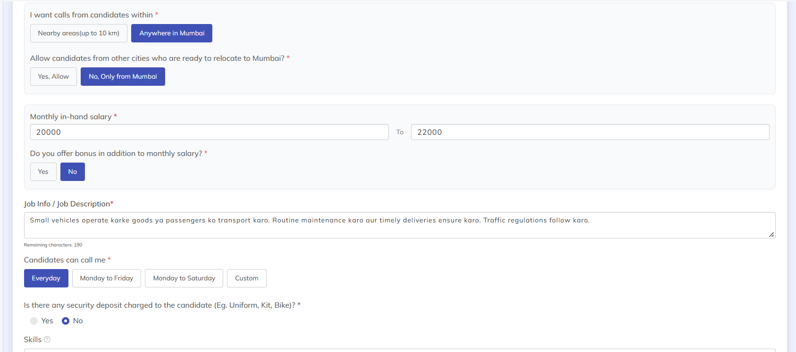

Job Type :
- Accountant
- Articleship
- Back Office
- Beautician
- Business Development
- Computer Operator
- Content Writing
- Cook
- Counsellor
- Counter Sales Job
- Data Entry
- Delivery
- Digital Marketing
- Driver
- Engineer (Mechanical / Civil etc.)
- Finance
- Field Sales
- Graphic Designer
- Government
- Hardware Engineer
- Hotel Management
- Hotel / Waiter
- Housekeeping
- HR Executive
- Lab Technician
- Maid
- Marketing
- Medical (Doctor, Dentist etc.)
- Nursing
- Office Boy
- Peon
- Receptionist
- Retail
- Sales Executive
- Security Guard
- Software Developer
- Teacher
- Technician
- Telecalling/BPO
- Trainer
- Other
- Find Work From Home Jobs By Type
- Accountant
- Articleship
- Back Office
- Beautician
- Business Development
- Computer Operator
- Content Writing
- Cook
- Counsellor
- Counter Sales Job
- Data Entry
- Delivery
- Digital Marketing
- Driver
- Engineer (Mechanical / Civil etc.)
- Finance
- Graphic Designer
- Government
- Hardware Engineer
- Hotel Management
- Hotel / Waiter
- Housekeeping
- HR Executive
- Lab Technician
- Maid
- Marketing
- Medical (Doctor, Dentist etc.)
- Nursing
- Office Boy
- Peon
- Receptionist
- Retail
- Sales Executive
- Security Guard
- Software Developer
- Teacher
- Technician
- Telecalling/BPO
- Trainer
- Other

Candidate Onboarding :
Step 1 :Enter mobile number and verify OTP => generate jwt token and go to jobs page
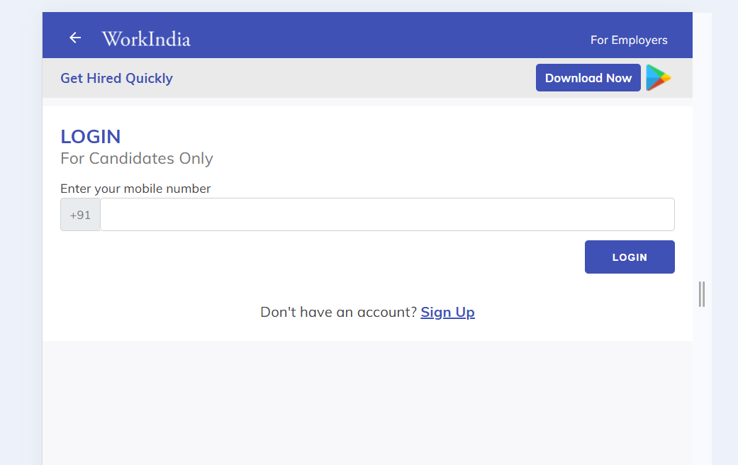

Step 2 : Jobs dashboard 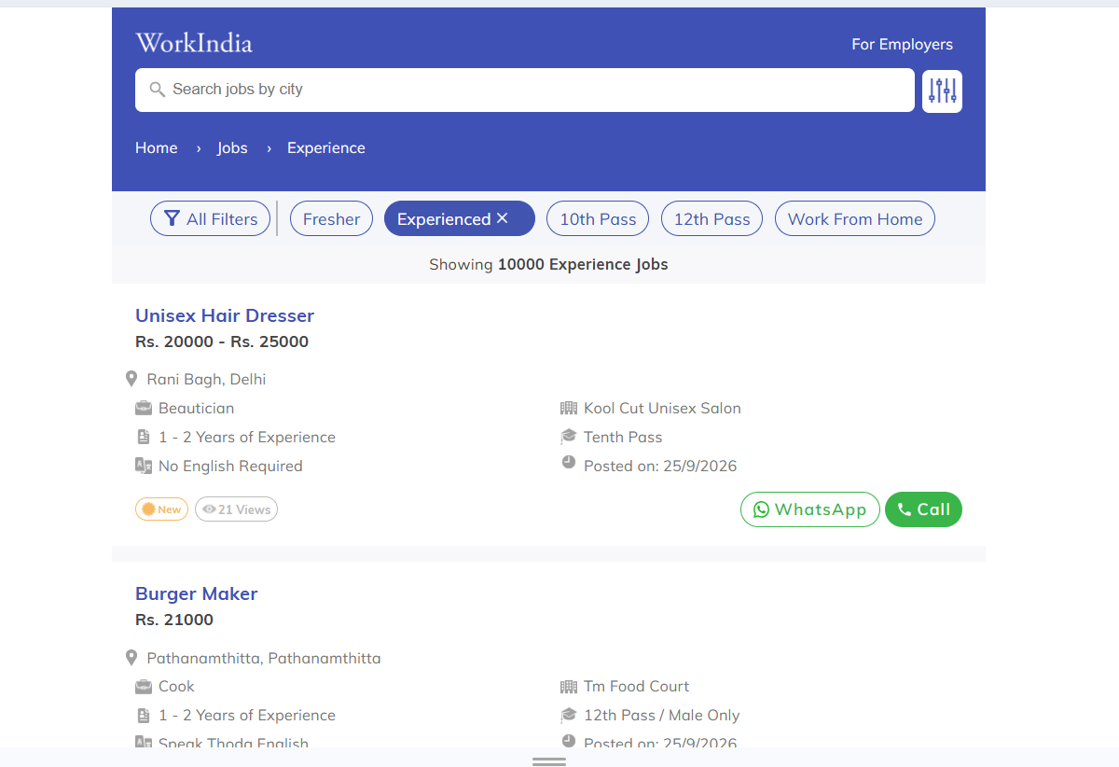

Step 3 : Filters :
- Jobs by industry
- Jobs by qualification
- Jobs by experience
- Jobs by work type
- Jobs by gender
- Jobs by degree
- More filters => airport, urgent, Iti, private

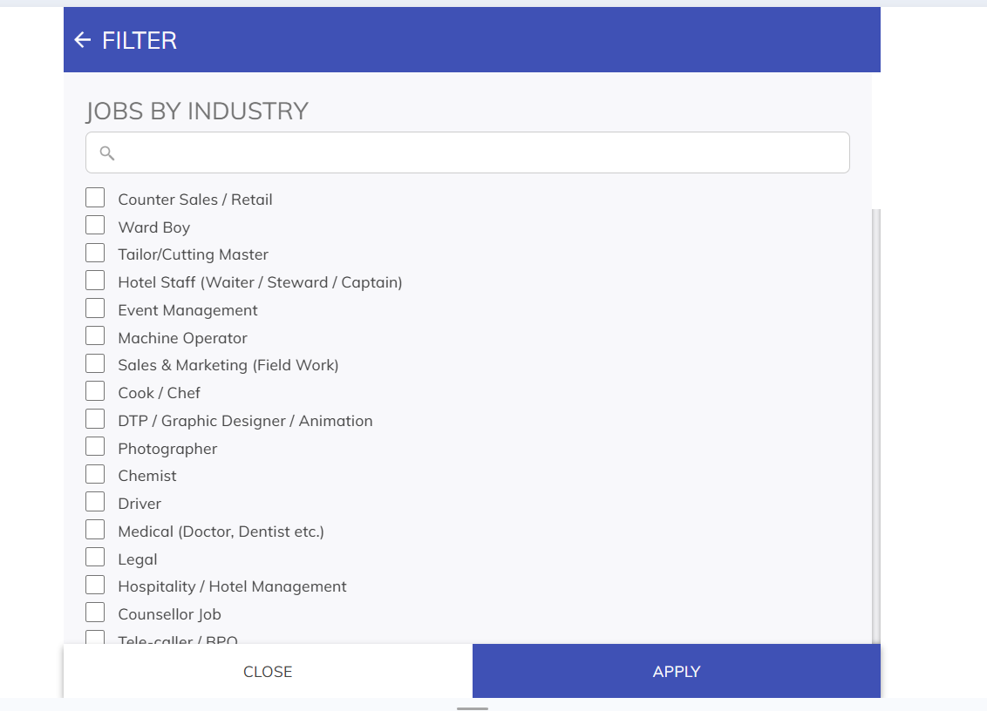
Job filters :
{
"filters": {
"industry": [
{
"link": "tailor-jobs/",
"name": "Tailor/Cutting Master",
"constant_name": "tailor",
"current": false,
"count": null
},
{
"link": "back-office-jobs/",
"name": "Back Office",
"constant_name": "back_office",
"current": false,
"count": null
},
{
"link": "graphic-designer-jobs/",
"name": "DTP / Graphic Designer / Animation",
"constant_name": "graphic_designer",
"current": false,
"count": null
},
{
"link": "maid-jobs/",
"name": "Maid",
"constant_name": "maid",
"current": false,
"count": null
},
{
"link": "hr-jobs/",
"name": "Human Resource / HR Executive",
"constant_name": "hr",
"current": false,
"count": null
},
{
"link": "cook-jobs/",
"name": "Cook / Chef",
"constant_name": "cook",
"current": false,
"count": null
},
{
"link": "dtp-jobs/",
"name": "DTP Operator",
"constant_name": "dtp",
"current": false,
"count": null
},
{
"link": "typist-jobs/",
"name": "Typist",
"constant_name": "typist",
"current": false,
"count": null
},
{
"link": "counsellor-jobs/",
"name": "Counsellor Job",
"constant_name": "counsellor",
"current": false,
"count": null
},
{
"link": "engineer-jobs/",
"name": "Engineer (Mechanical, Civil etc.)",
"constant_name": "engineer",
"current": false,
"count": null
},
{
"link": "field-sales-jobs/",
"name": "Sales & Marketing (Field Work)",
"constant_name": "field_sales",
"current": false,
"count": null
},
{
"link": "machine-operator-jobs/",
"name": "Machine Operator",
"constant_name": "machine_operator",
"current": false,
"count": null
},
{
"link": "hospitality-jobs/",
"name": "Hospitality / Hotel Management",
"constant_name": "hospitality",
"current": false,
"count": null
},
{
"link": "retail-jobs/",
"name": "Counter Sales / Retail",
"constant_name": "retail",
"current": false,
"count": null
},
{
"link": "driver-jobs/",
"name": "Driver",
"constant_name": "driver",
"current": false,
"count": null
},
{
"link": "online-marketing-jobs/",
"name": "Digital Marketing",
"constant_name": "online_marketing",
"current": false,
"count": null
},
{
"link": "chemist-jobs/",
"name": "Chemist",
"constant_name": "chemist",
"current": false,
"count": null
},
{
"link": "ward-boy-jobs/",
"name": "Ward Boy",
"constant_name": "ward_boy",
"current": false,
"count": null
},
{
"link": "legal-jobs/",
"name": "Legal",
"constant_name": "legal",
"current": false,
"count": null
},
{
"link": "housekeeping-jobs/",
"name": "Housekeeping",
"constant_name": "housekeeping",
"current": false,
"count": null
},
{
"link": "hotel-jobs/",
"name": "Hotel Staff (Waiter / Steward / Captain)",
"constant_name": "hotel",
"current": false,
"count": null
},
{
"link": "telecalling-jobs/",
"name": "Tele-caller / BPO",
"constant_name": "telecalling",
"current": false,
"count": null
},
{
"link": "security-guard-jobs/",
"name": "Security Guard",
"constant_name": "security_guard",
"current": false,
"count": null
},
{
"link": "office-boy-peon-jobs/",
"name": "Office Boy / Peon / Helper",
"constant_name": "office_boy_peon",
"current": false,
"count": null
},
{
"link": "hardware-engineer-jobs/",
"name": "IT Hardware & Network Engineer",
"constant_name": "hardware_engineer",
"current": false,
"count": null
},
{
"link": "medical-jobs/",
"name": "Medical (Doctor, Dentist etc.)",
"constant_name": "medical",
"current": false,
"count": null
},
{
"link": "marketing-jobs/",
"name": "Marketing",
"constant_name": "marketing",
"current": false,
"count": null
},
{
"link": "event-management-jobs/",
"name": "Event Management",
"constant_name": "event_management",
"current": false,
"count": null
},
{
"link": "lab-technician-jobs/",
"name": "Lab Technician",
"constant_name": "lab_technician",
"current": false,
"count": null
},
{
"link": "other-jobs/",
"name": "Other",
"constant_name": "other",
"current": false,
"count": null
},
{
"link": "labourer-jobs/",
"name": "Labourer",
"constant_name": "labourer",
"current": false,
"count": null
},
{
"link": "photographer-jobs/",
"name": "Photographer",
"constant_name": "photographer",
"current": false,
"count": null
},
{
"link": "content-writing-jobs/",
"name": "Content Writing",
"constant_name": "content_writing",
"current": false,
"count": null
},
{
"link": "technician-jobs/",
"name": "Technician/ITI (AC, CCTV etc.)",
"constant_name": "technician",
"current": false,
"count": null
},
{
"link": "programmer-jobs/",
"name": "Software / Web Developer",
"constant_name": "programmer",
"current": false,
"count": null
},
{
"link": "teacher-jobs/",
"name": "Teacher",
"constant_name": "teacher",
"current": false,
"count": null
},
{
"link": "business-development-jobs/",
"name": "Business Development",
"constant_name": "business_development",
"current": false,
"count": null
},
{
"link": "receptionist-jobs/",
"name": "Receptionist / Front Office Desk",
"constant_name": "receptionist",
"current": false,
"count": null
},
{
"link": "vehicle-service-jobs/",
"name": "Vehicle Service",
"constant_name": "vehicle_service",
"current": false,
"count": null
},
{
"link": "delivery-jobs/",
"name": "Delivery / Pick Up Boy",
"constant_name": "delivery",
"current": false,
"count": null
},
{
"link": "trainer-jobs/",
"name": "Trainer",
"constant_name": "trainer",
"current": false,
"count": null
},
{
"link": "accounts-jobs/",
"name": "Accounts",
"constant_name": "accounts",
"current": false,
"count": null
},
{
"link": "fashion-designer-jobs/",
"name": "Fashion Designer",
"constant_name": "fashion_designer",
"current": false,
"count": null
},
{
"link": "architect-jobs/",
"name": "Architect/Interiors",
"constant_name": "architect",
"current": false,
"count": null
},
{
"link": "beautician-jobs/",
"name": "Beautician / Hair Stylist / Salon",
"constant_name": "beautician",
"current": false,
"count": null
},
{
"link": "nurse-jobs/",
"name": "Nurse / Ward Boy / Patient Care",
"constant_name": "nurse",
"current": false,
"count": null
}
],
"qualification": [
{
"link": "below-10th-pass-jobs/",
"name": "Below 10th Pass",
"constant_name": "1",
"current": false,
"count": null
},
{
"link": "10th-pass-jobs/",
"name": "10th Pass",
"constant_name": "2",
"current": false,
"count": null
},
{
"link": "12th-pass-jobs/",
"name": "12th Pass",
"constant_name": "3",
"current": false,
"count": null
},
{
"link": "graduate-jobs/",
"name": "Graduate",
"constant_name": "4",
"current": false,
"count": null
}
],
"experience": [
{
"link": "experience-jobs/",
"name": "Experienced",
"constant_name": "experience",
"current": false,
"count": null
},
{
"link": "fresher-jobs/",
"name": "Fresher",
"constant_name": "fresher",
"current": false,
"count": null
}
],
"work_type": [
{
"link": "work-from-home-jobs/",
"name": "Work From Home",
"constant_name": "work_from_home",
"current": false,
"count": null
},
{
"link": "work-from-office-jobs/",
"name": "Work From Office",
"constant_name": "work_from_office",
"current": false,
"count": null
},
{
"link": "part-time-jobs/",
"name": "Part Time",
"constant_name": "part_time",
"current": false,
"count": null
},
{
"link": "full-time-jobs/",
"name": "Full Time",
"constant_name": "full_time",
"current": false,
"count": null
},
{
"link": "student-jobs/",
"name": "Student",
"constant_name": "student",
"current": false,
"count": null
}
],
"location": [],
"gender": [
{
"link": "female-jobs/",
"name": "Women",
"constant_name": "female",
"current": false,
"count": null
}
],
"text_search": [
{
"link": "airport-jobs/",
"name": "Airport",
"constant_name": "airport",
"current": false,
"count": null
},
{
"link": "urgent-jobs/",
"name": "Urgent",
"constant_name": "urgent",
"current": false,
"count": null
},
{
"link": "iti-jobs/",
"name": "Iti",
"constant_name": "iti",
"current": false,
"count": null
},
{
"link": "private-jobs/",
"name": "Private",
"constant_name": "private",
"current": false,
"count": null
}
],
"course": [
{
"link": "ca-jobs/",
"name": "Ca",
"constant_name": "ca",
"current": false,
"count": null
},
{
"link": "mba-jobs/",
"name": "Mba",
"constant_name": "mba",
"current": false,
"count": null
},
{
"link": "btech-jobs/",
"name": "Btech",
"constant_name": "btech",
"current": false,
"count": null
},
{
"link": "bcom-jobs/",
"name": "Bcom",
"constant_name": "bcom",
"current": false,
"count": null
},
{
"link": "bsc-jobs/",
"name": "Bsc",
"constant_name": "bsc",
"current": false,
"count": null
},
{
"link": "be-jobs/",
"name": "Be",
"constant_name": "be",
"current": false,
"count": null
}
],
"job_title": [
{
"link": "jobs/",
"name": "Electrical-Engineer",
"constant_name": "electrical_engineer",
"current": false,
"count": null
},
{
"link": "jobs/",
"name": "Mis-Executive",
"constant_name": "mis_executive",
"current": false,
"count": null
},
{
"link": "jobs/",
"name": "Full-Stack-Developer",
"constant_name": "full_stack_developer",
"current": false,
"count": null
},
{
"link": "jobs/",
"name": "Civil-Engineer",
"constant_name": "civil_engineer",
"current": false,
"count": null
},
{
"link": "jobs/",
"name": "Mechanical-Engineer",
"constant_name": "mechanical_engineer",
"current": false,
"count": null
}
],
"city": null
},
"editorial_content": null,
"qa_content": null
}

Step 4 : Job alert on whatsapp
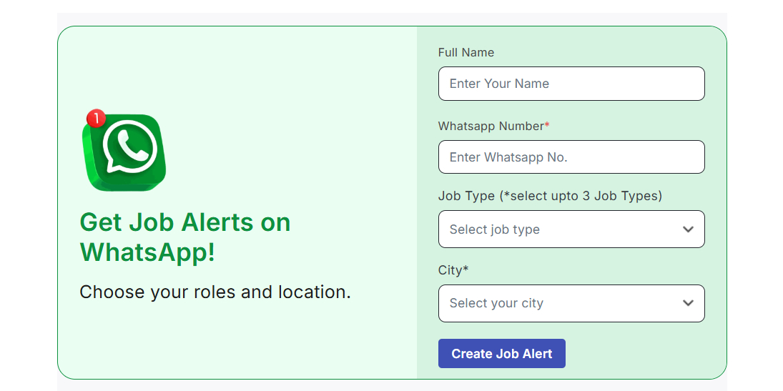
Step 5: Resume builder

Step 6: Footer

Find jobs in your city
Find work from home jobs in your city

Top Industry jobs
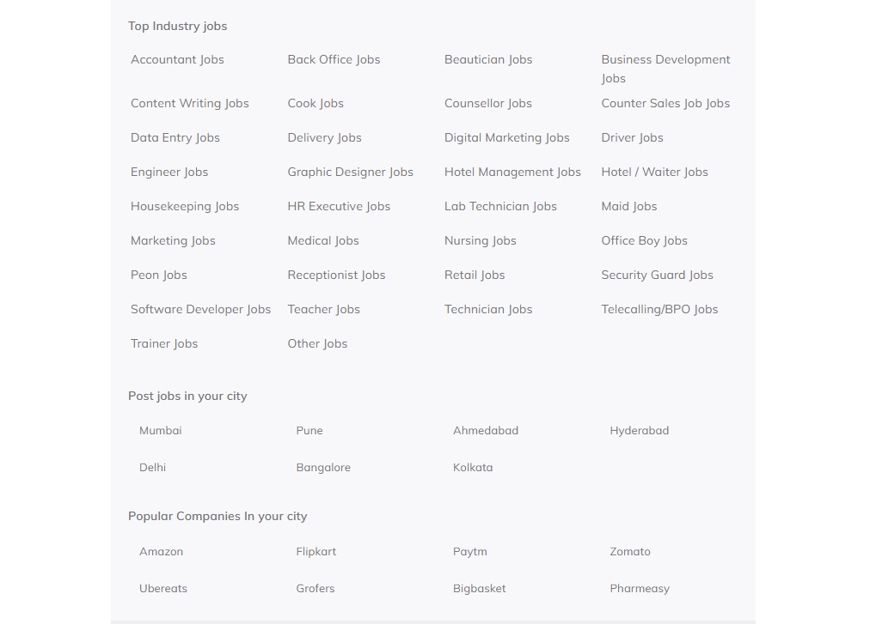

Step 7 : Click job card and check job details
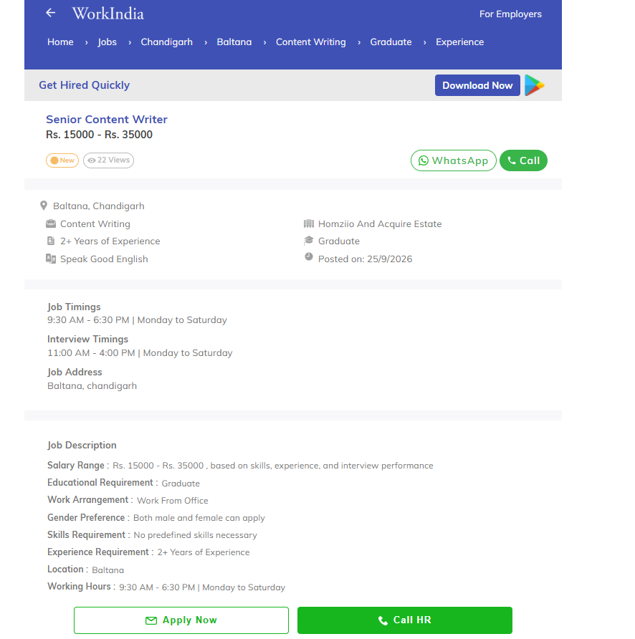

Share job with friends, via whatsapp,facebook,telegram
Step 8: Apply now or call HR
